Word sense disambiguation, in natural language processing (NLP), may be defined as the ability to determine which meaning of word is activated by the use of word in a particular context. Lexical ambiguity, syntactic or semantic, is one of the very first problem that any NLP system faces. Part-of-speech (POS) taggers with high level of accuracy can solve Word’s syntactic ambiguity. On the other hand, the problem of resolving semantic ambiguity is called WSD (word sense disambiguation). Resolving semantic ambiguity is harder than resolving syntactic ambiguity.

For example, consider the two examples of the distinct sense that exist for the word “bass” −

I can hear bass sound.

He likes to eat grilled bass.

Typically, there are two kinds of approach for WSD: supervised (which make use of sense-annotated training data) and knowledge-based (which make use of the properties of lexical resources).

Supervised: The most widely used training corpus used is SemCor, with 226,036 sense annotations from 352 documents manually annotated. All supervised systems in the evaluation table are trained on SemCor. Some supervised methods, particularly neural architectures, usually employ the SemEval 2007 dataset as development set (marked by \*). The most usual baseline is the Most Frequent Sense (MFS) heuristic, which selects for each target word the most frequent sense in the training data.

Knowledge-based: Knowledge-based systems usually exploit WordNet or BabelNet as semantic network. The first sense given by the underlying sense inventory (i.e. WordNet 3.0) is included as a baseline.

The main evaluation measure is F1-score.

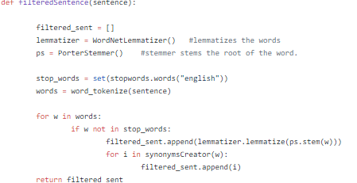

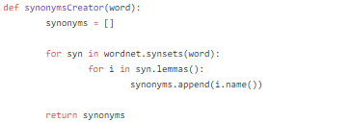

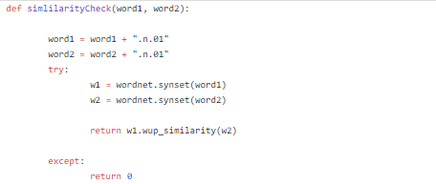

Followings are some difficulties faced by word sense disambiguation (WSD) −

Differences between dictionaries

The major problem of WSD is to decide the sense of the word because different senses can be very closely related. Even different dictionaries and thesauruses can provide different divisions of words into senses.

Different algorithms for different applications

Another problem of WSD is that completely different algorithm might be needed for different applications. For example, in machine translation, it takes the form of target word selection; and in information retrieval, a sense inventory is not required.

Inter-judge variance

Another problem of WSD is that WSD systems are generally tested by having their results on a task compared against the task of human beings. This is called the problem of interjudge variance.

Word-sense discreteness

Another difficulty in WSD is that words cannot be easily divided into discrete submeanings.